Q4

**Clustered index on Author:**

CREATE INDEX ind1 on Author(auth_name) CLUSTER

DESCRIBE INDEXES FOR TABLE Author

This index is useful for the database because the user may want to search the database just by author name and not author id (primary key) or any other attribute.

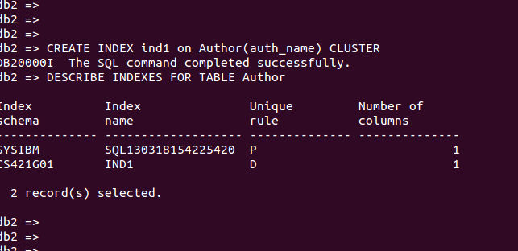

**Index on multiple attributes on table Books:**

CREATE INDEX ind2 ON Books(title,shelf_no)

DESCRIBE INDEXES FOR TABLE Books

This index is useful as it would show us quicker results when the user would want to search a book only by title and find its corresponding shelf no.  Here data entries are first ordered by title and then by shelf_no

